**Answer Sheet - SQL**

Name : Kirankumar R G

Phone No. : 8497890044

Email : kirankumar1995rg@gmail.com

**Major Question 1**

1. List the salary of all the employees.

select ename as employees_Name, salary

from employee;

Insert Image-

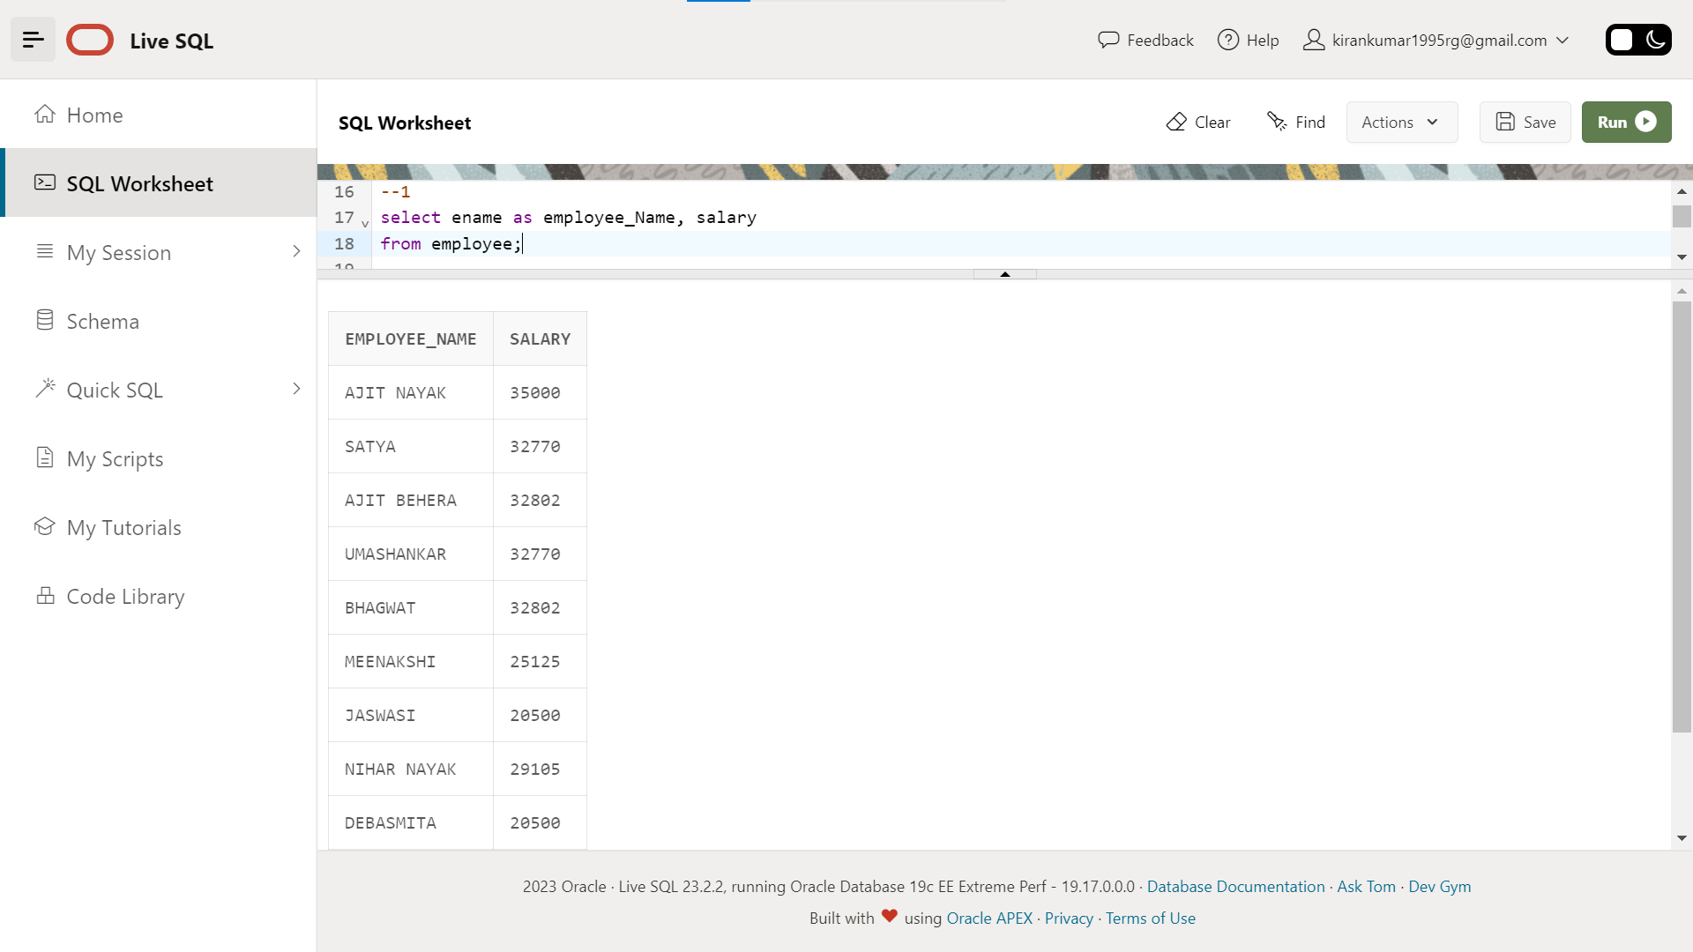

1. Display the names of all employees with any “A” at any place of the name.

select ename as Employee_Name

from employee

where ename like 'A%' --A% gives text starting from letter A

or ename like '%A' --%A gives text ending with letter A

or ename like '%A%'; --%A% gives A containing in middle of text

Insert Image –

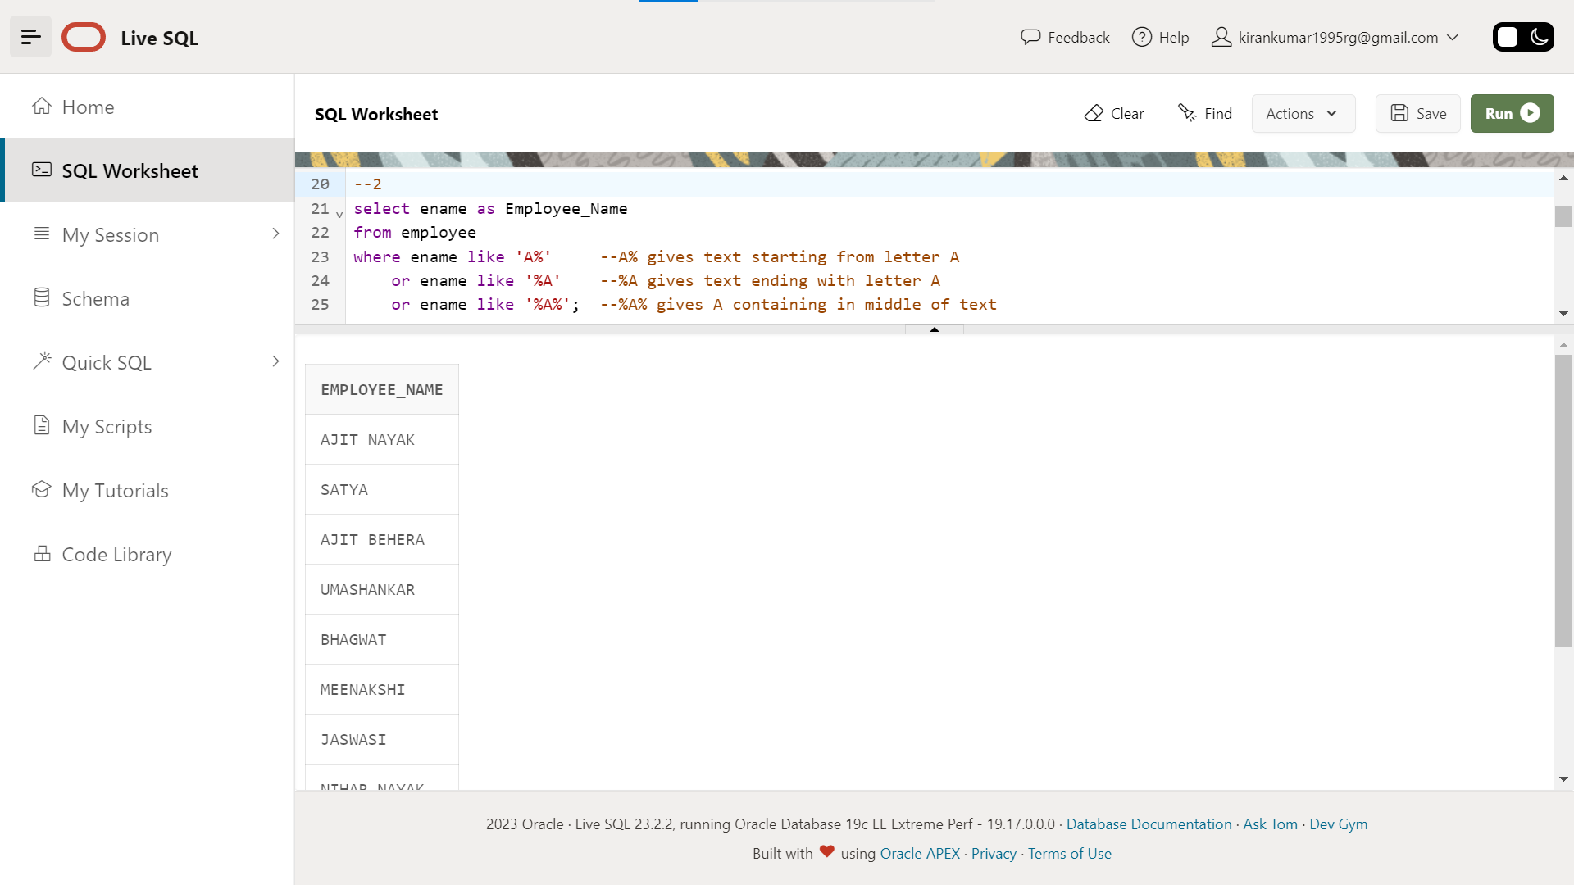

1. Show all employees who were hired in the first half of the month (Before the 16th of the month).

select *

from (select em.ename as emp_name,em.esrno,dp.mgrstartd,extract(day from dp.mgrstartd) as date_of_join

from employee em

inner join department dp

on em.dno = dp.dnumber)

where date_of_join < 16;

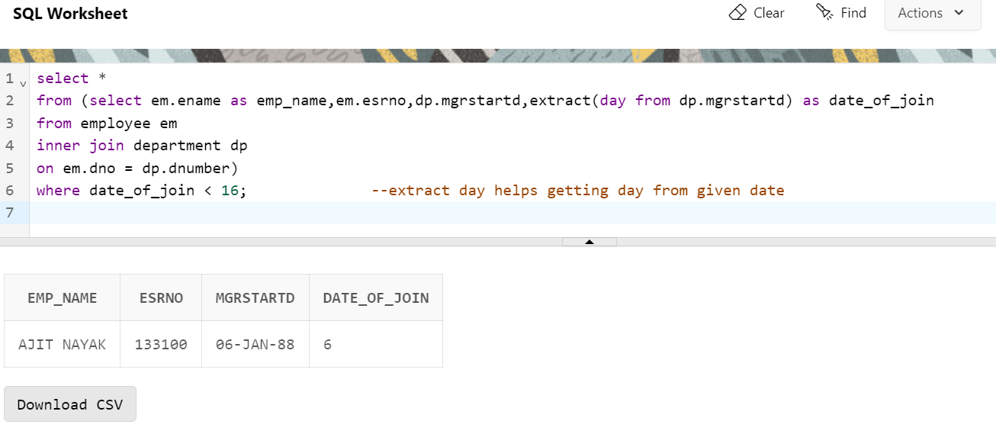Insert Image -

1. Display the name of all female employees.

select ename as employee_name, address,esrno

from employee

where sex='F'; --feltering done based on sex

Insert Image -

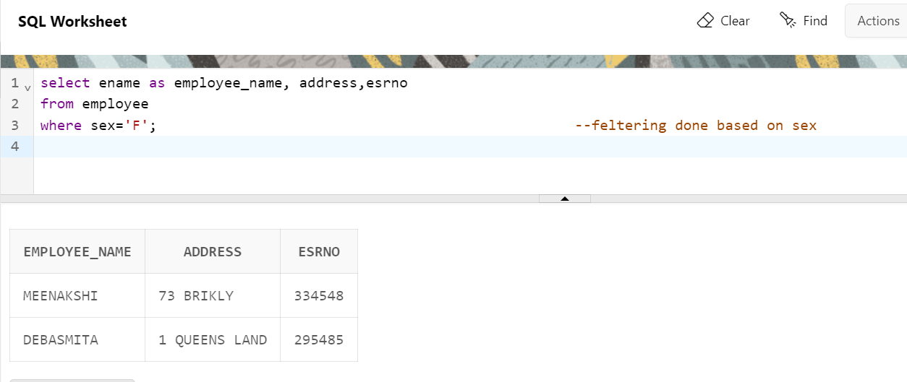

1. Display the employee who is paid most in the company.

--5 1st method

select employee_name,salary

from(select ename as Employee_name,salary,

dense_rank() over (order by salary desc) as rank --definesd subquery and assigned rank from max to min salary

from employee)

where rank = 1 ; --since we need max salary we assigning rank = 1

--another method

select ename as Employee_name,salary

from employee

where salary = (select max(salary) --created a column having max salary and assigned max salary to salary column

from employee)

Insert Image –

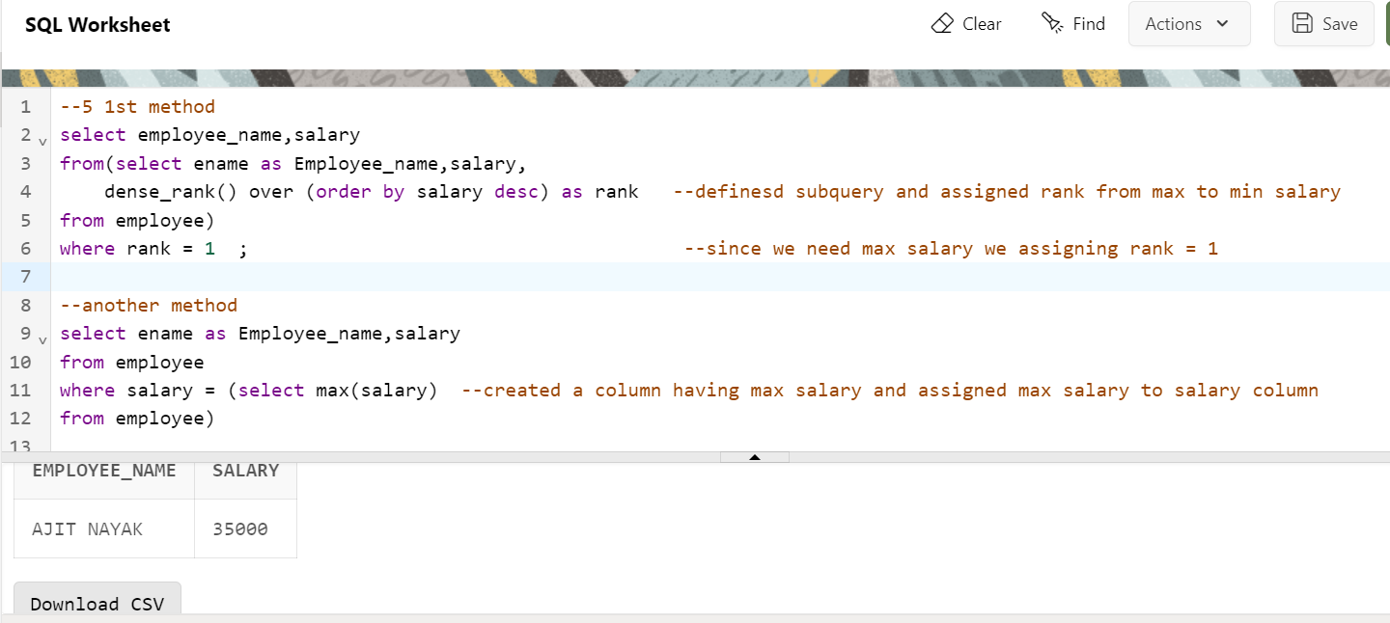

Note : *I have solved this question by using 2 methods*

1. *Using window function and subquery*
2. *Using subquery and filtering*

**Major Question 2**

1. Display employee name, address, department no and department name.

select em.ename as employee_name,address,dp.dnumber as dept_no, dp.dname as depart_name

from employee em

inner join department dp --two tables has been joined by using join funct

on em.dno = dp.dnumber

Insert Image –

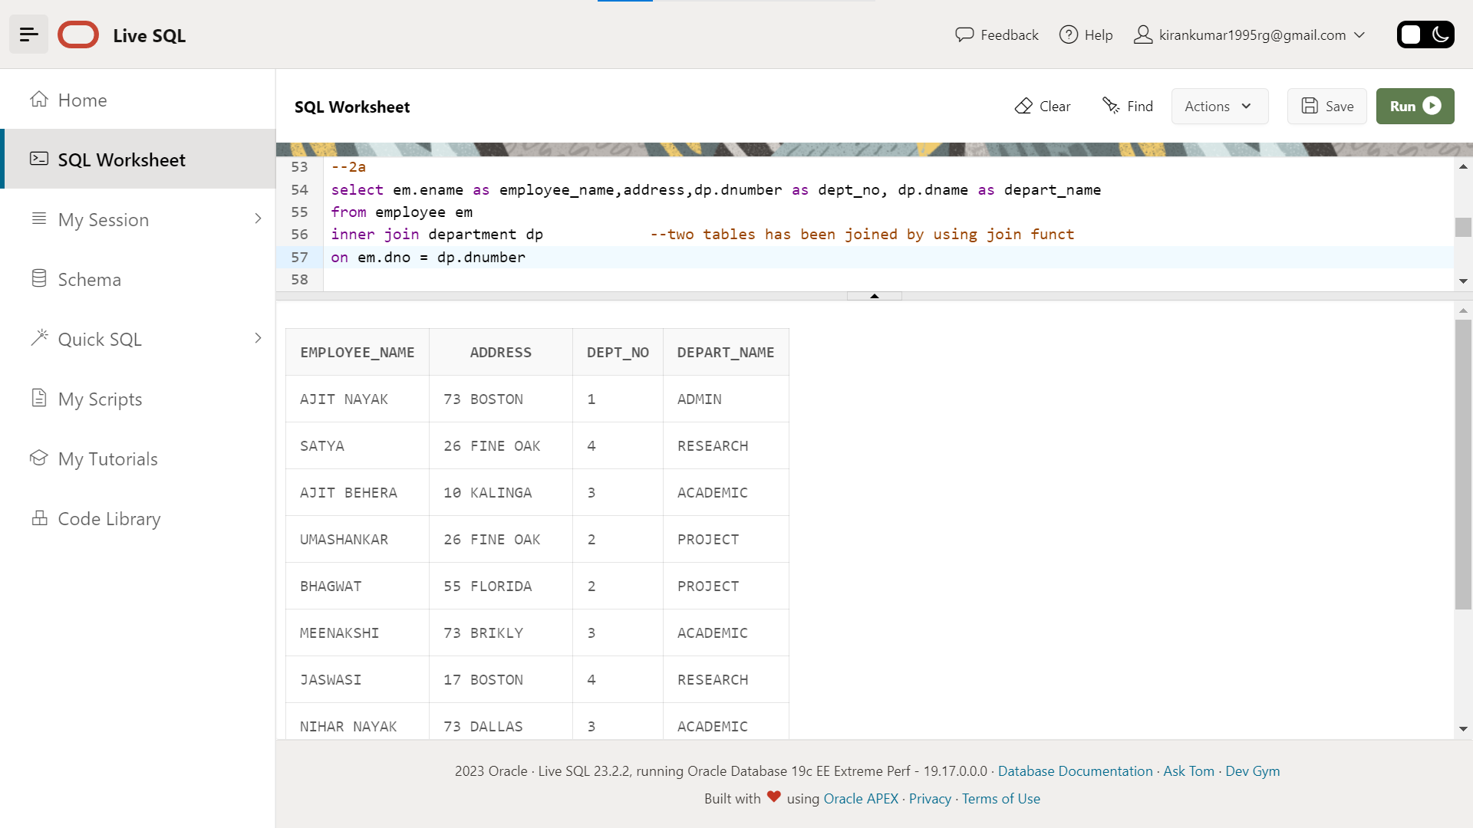

1. Display all the employees who are *not in* ACADEMIC department

select * --* all the columns from the table

from (select em.ename as employee_name,address,dp.dnumber as dept_no, dp.dname as dept_name

from employee em

inner join department dp

on em.dno = dp.dnumber) --in subquery we have joined two tables

where dept_name != 'ACADEMIC'; --applied the filter not equal to 'academic' to the subquery table

Insert Image –

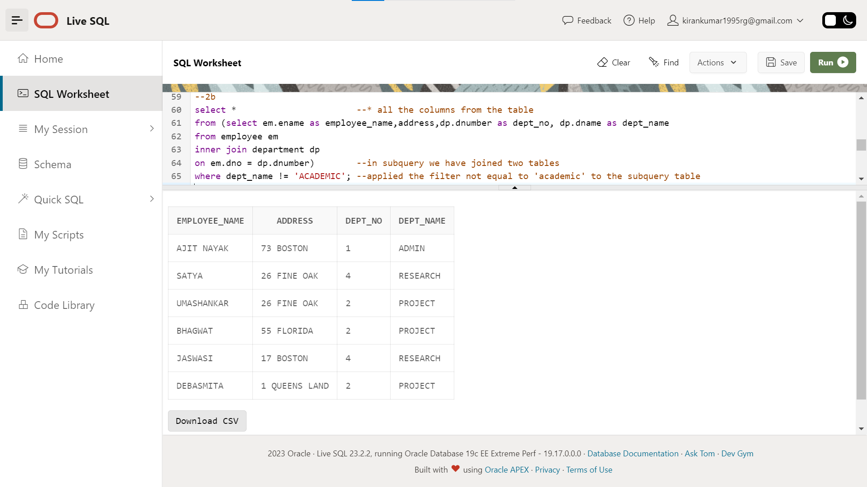

1. Display SATYAS’ project location.

select em.ename as Emp_name, em.address,dl.plocation

from employee em

inner join project dl --join funct to join taables

on em.dno = dl.dnum

where ename = 'SATYA'; --applied filter for ename column

Insert Image -

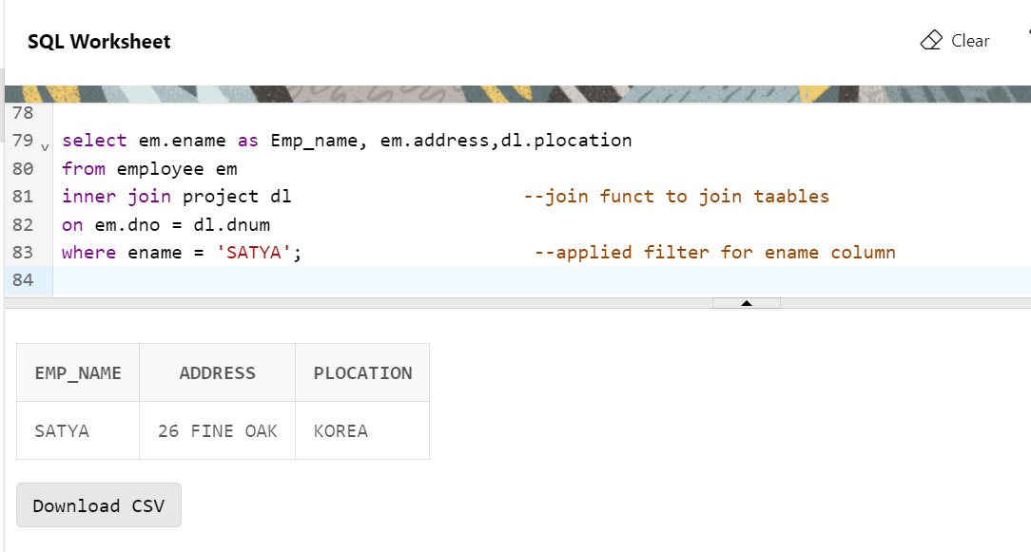

1. Find the total working hours of *each* female employee.

select ename,sex, total_hours

from(

select em.ename,em.sex,sum(w.hours) as total_hours,em.esrno

from employee em

right join works_on w

on em.esrno = w.esrno

group by em.ename,em.esrno,em.sex) --in subquery we have joined two table and cal the total working hours on each employee

where sex = 'F' ; -- feltering done to subquery table based on gender

Insert Image -

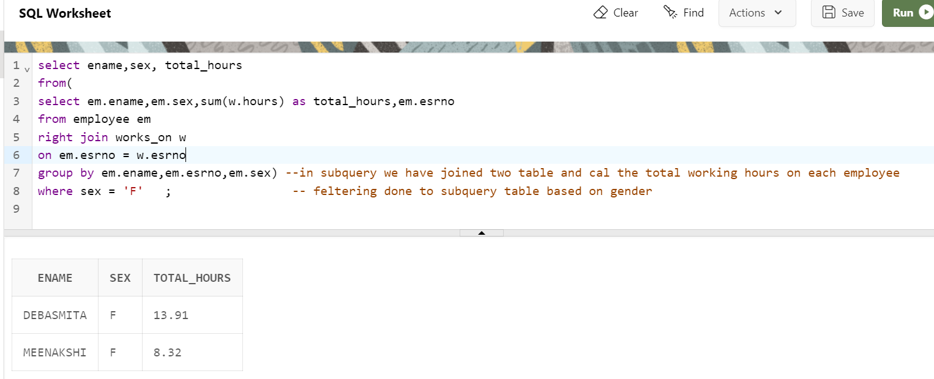

1. Display the details of the people whose projects are located at SOUTH AFRICA.

select * -- '*' is used to get details of each employee

from employee em

inner join project p --joining the two table

on em.dno = p.dnum

where plocation = 'SOUTH AFRICA' --filtering done based on project location

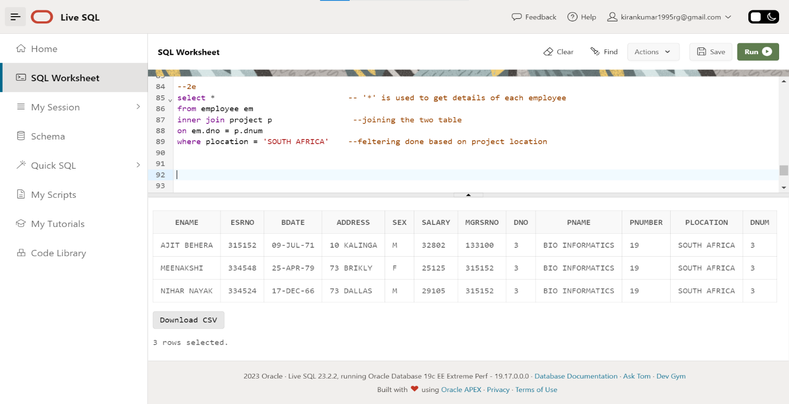 Insert Image –